Ava Powers
Project Report 2
The first task in my data analysis was to load the data file and print the names of the columns. The names of the columns include the following: "user_id","name","review_count" ,"average_stars","cool_votes", "funny_votes","useful_votes" ,"friends", "elite", "yelping_since","fans" .
The second task in my data analysis was to perform a Pearson's correlation coefficient test to determine if there was a correlation between cool_votes, useful_votes, and funny_votes. After running the analysis, it can be concluded that all three are significantly correlated with each other, with cool_votes and useful votes having a correlation score of 0.98, and cool_votes and funny_votes having a correlation score of 0.97.
The third task in my data analysis was to perform a linear regression analysis between cool_votes and funny_votes and graph the results including a line of best fit.
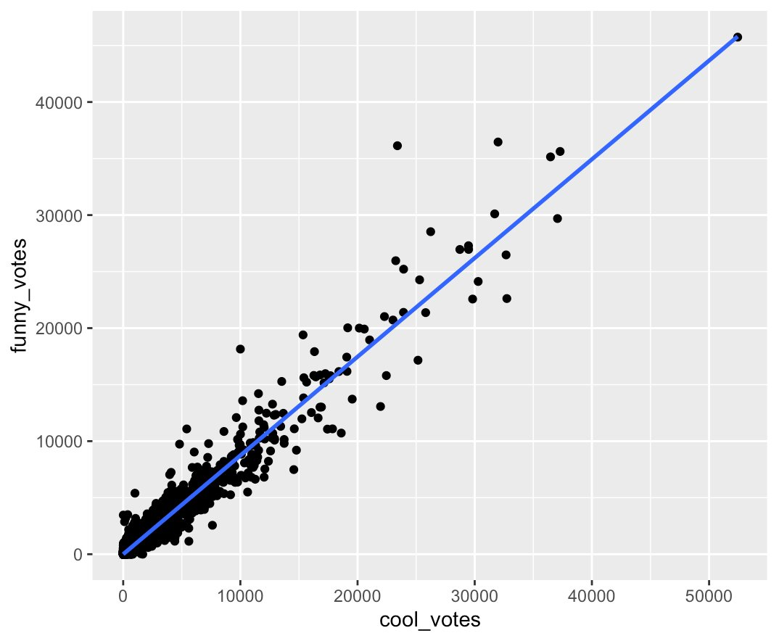
After running the analysis, it can be concluded that cool and funny votes are very highly correlated, with a correlation score of 1.09.
The fourth task in my data analysis was to perform another linear regression analysis to determine whether or not review_counts could bring in more fans.
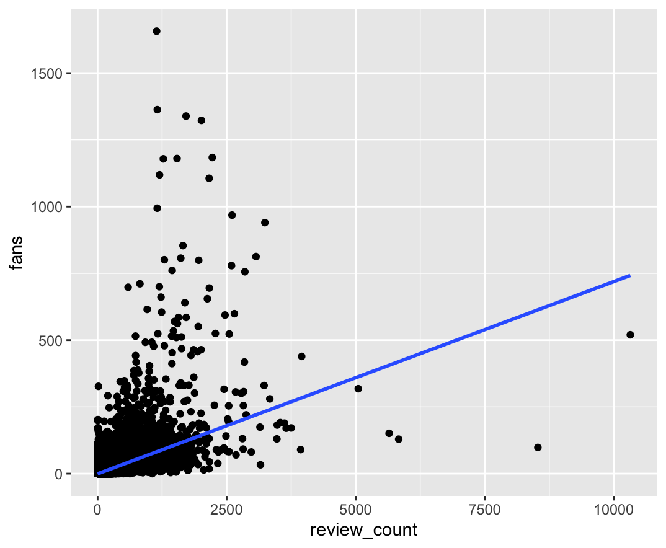
After running an analysis, it can be concluded that review_count does not necessarily determine the amount of fans a business on Yelp can bring in.
The fifth step in my data analysis was to run a third and final linear regression analysis to determine a different variable that could better determine what brought in more fans into a Yelp business besides review_count.
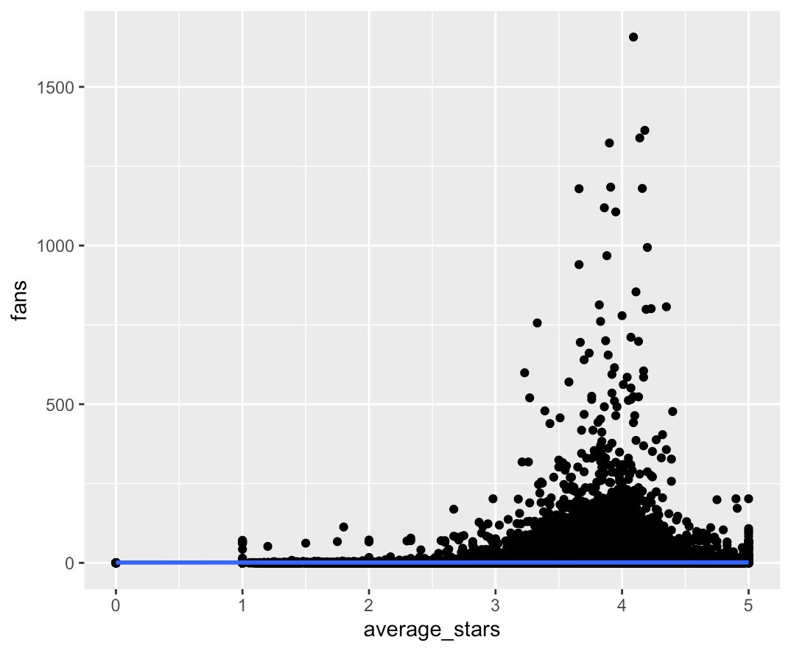
After conducting an analysis, it can be concluded that average stars, while it does not bring in many more fans, it brings in more fans that review_count.
The final step in my data analysis was to run a k-means machine learning algorithm to determine whether or not the data could be organized into clusters.
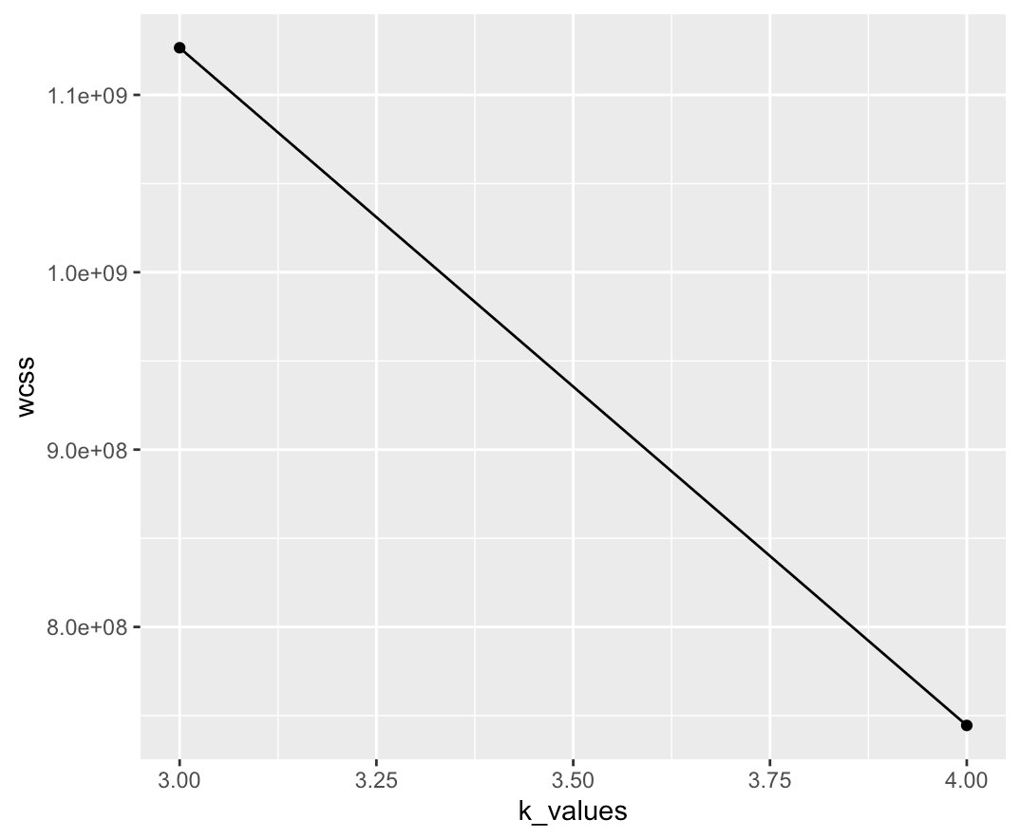
After running an analysis, it can not be concluded that clusters were successfully created with the data.

